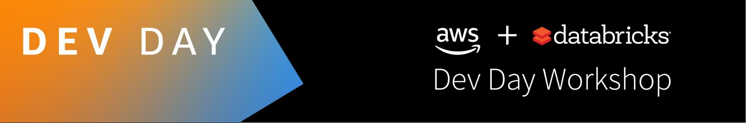

For this AWS Dev Day workshop, please download the following files so you can follow along with your Databricks Solution Architect with these notebooks. You can run these notebooks on your own after the workshop by using Databricks.

If you do not have a Databricks account, you can get your own free Databricks Community Edition (DBCE) account by going to <http://databricks.com/try-databricks>. Choose “**Community Edition**” (on the right).

To following along, you will need to download the following files:

1. Data Engineering: [Data Preparation with Delta Lake](https://dbricks.co/dlw-01)
2. Data Sciences: [Evaluate Risk on Loan Approvals](https://dbricks.co/dlw-02)

If you would like to dive further, you can also download the [Evaluate Risk on Loan Approvals (XGBoost 0.81)](https://dbricks.co/dlw-03) and try using XGBoost (included as part of [Databricks Runtime for Machine Learning](https://databricks.com/blog/2018/06/05/announcing-databricks-runtime-for-machine-learning.html)).

For more information on the Evaluate Risk on Loan Approvals scenario, refer to the blog post [Loan Risk Analysis with XGBoost and Databricks Runtime for Machine Learning](https://databricks.com/blog/2018/08/09/loan-risk-analysis-with-xgboost-and-databricks-runtime-for-machine-learning.html).

Refer to the following pages for additional details

**Import Data** **2**

**Data Engineering** **3**

**Data Sciences** **4**

# Import Data

To download the data, please uncomment the earlier cell in the notebook which will download the files using wget into the Databricks File System tmp folder (i.e. /dbfs/tmp) as noted in the following screenshot.

# 

Once downloaded, you can see the file via the following command.

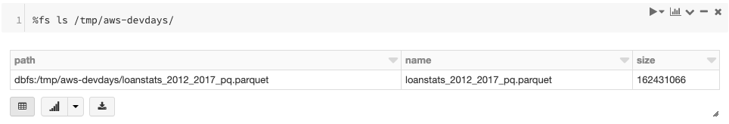

# Data Engineering

This demo showcases batch/streaming sync, ACID transactions, and time travel with Delta Lake. Download the notebook: [Data Preparation with Delta Lake](https://dbricks.co/dlw-01),

As well, click on the image below to watch a < 2 min video showcasing this scenario. You can access the video directly at <https://dbricks.co/dl-db>.

[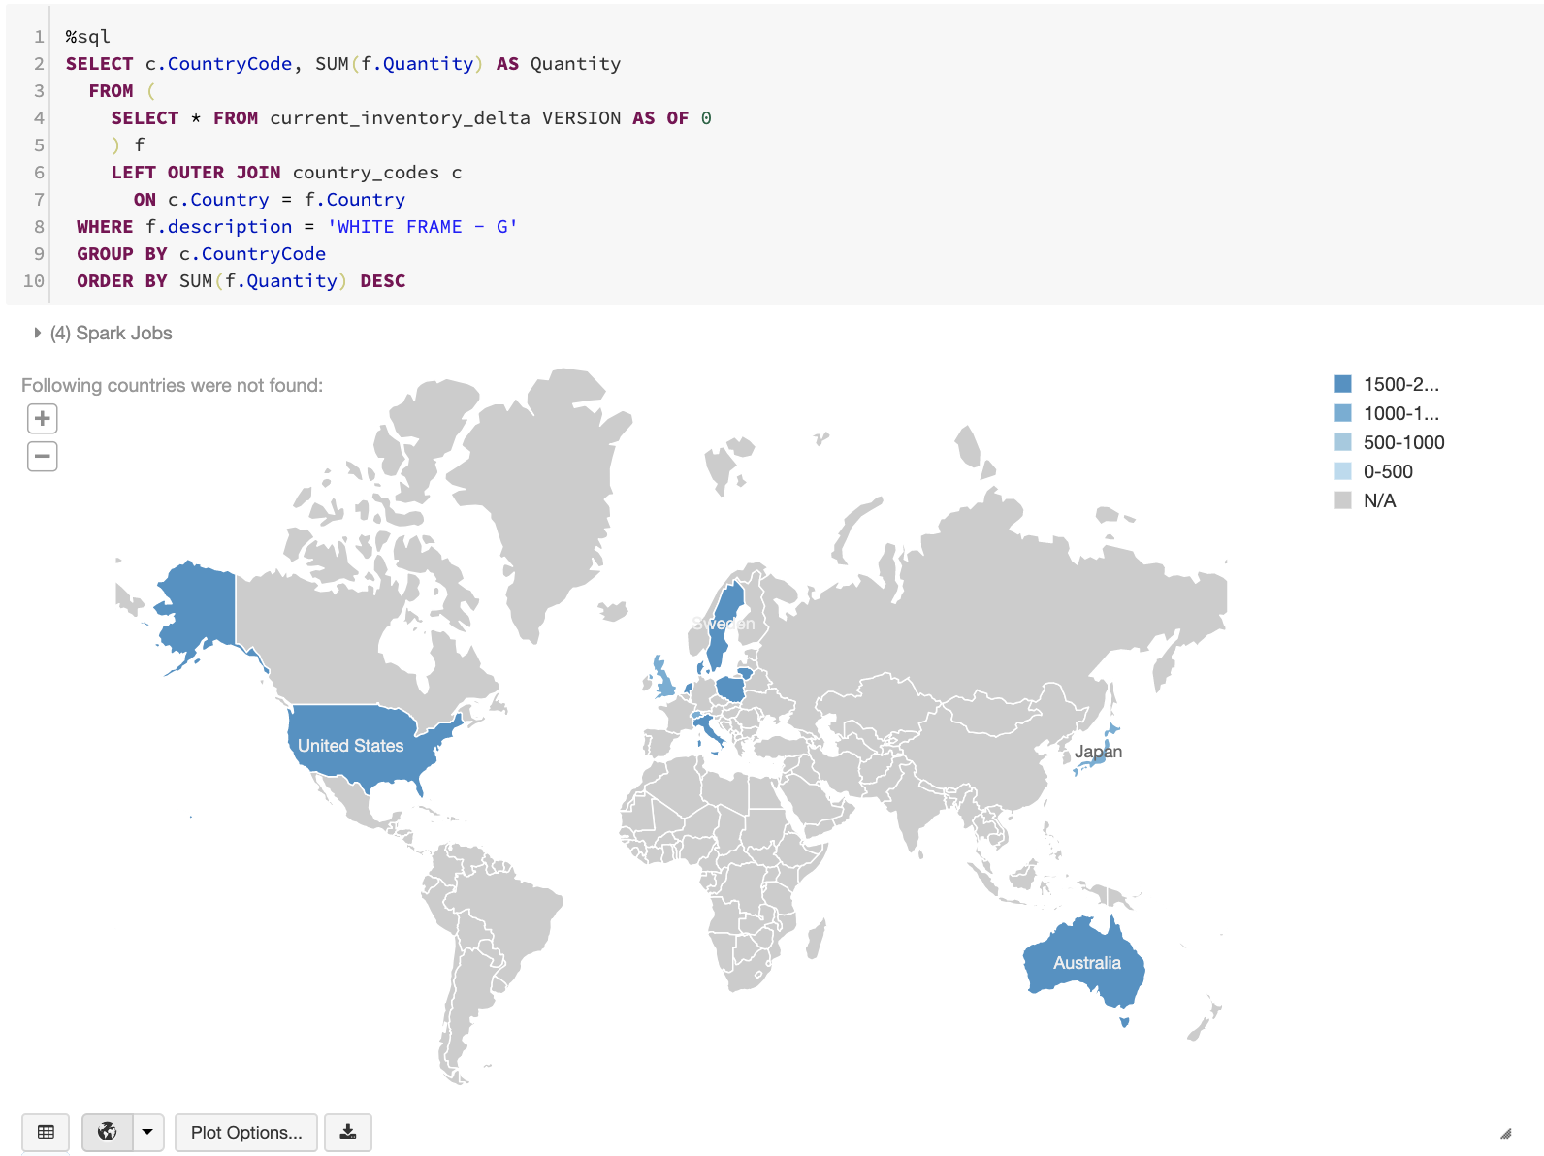](https://dbricks.co/dl-db)

# Data Sciences

This demo showcases running Machine Learning with visualizations within a Databricks workspace. Download the following notebooks and resources: [Evaluate Risk on Loan Approvals](https://dbricks.co/dlw-02).

If you would like to dive further, you can also download the [Evaluate Risk on Loan Approvals (XGBoost 0.81)](https://dbricks.co/dlw-03) and try using XGBoost (included as part of [Databricks Runtime for Machine Learning](https://databricks.com/blog/2018/06/05/announcing-databricks-runtime-for-machine-learning.html)).

As well, click on the image below to watch a < 2min video showing this scenario. You can access the video directly at <https://dbricks.co/lra-video>

[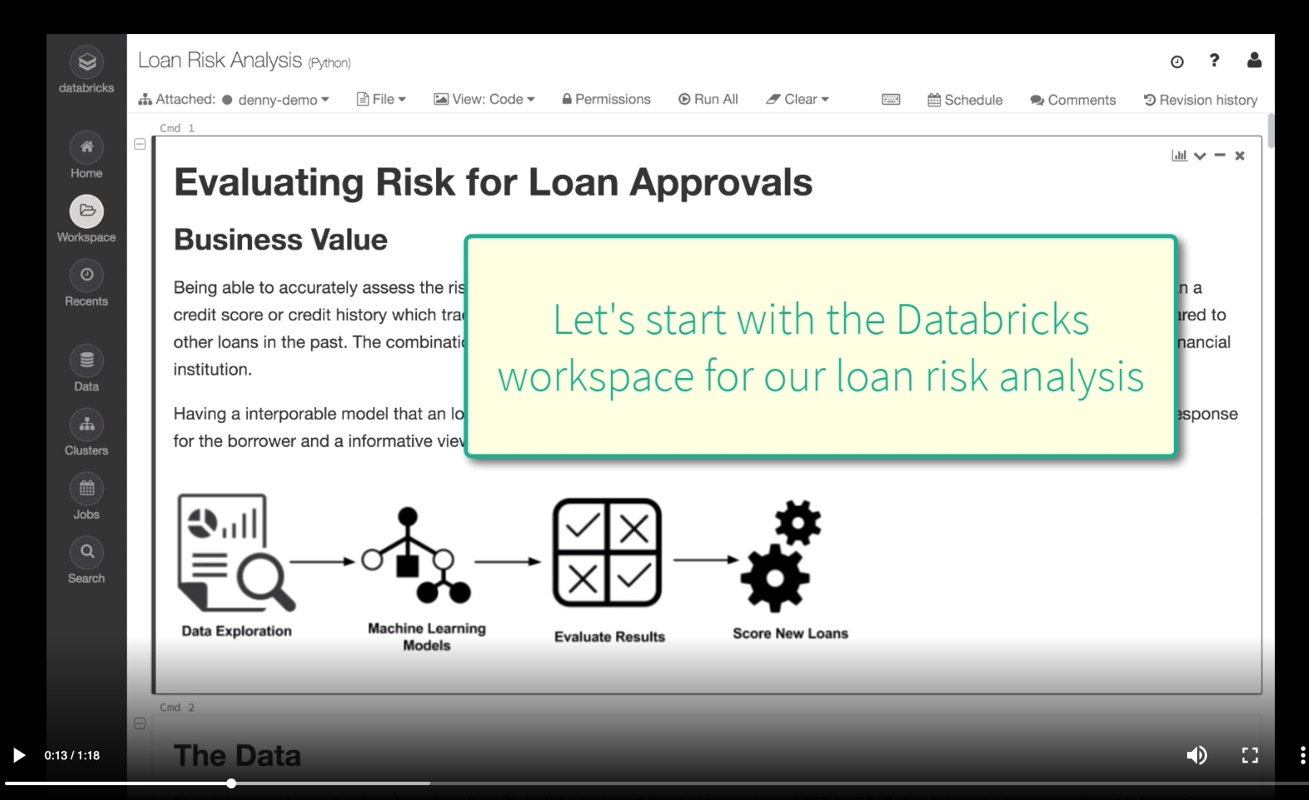](https://dbricks.co/lra-video)